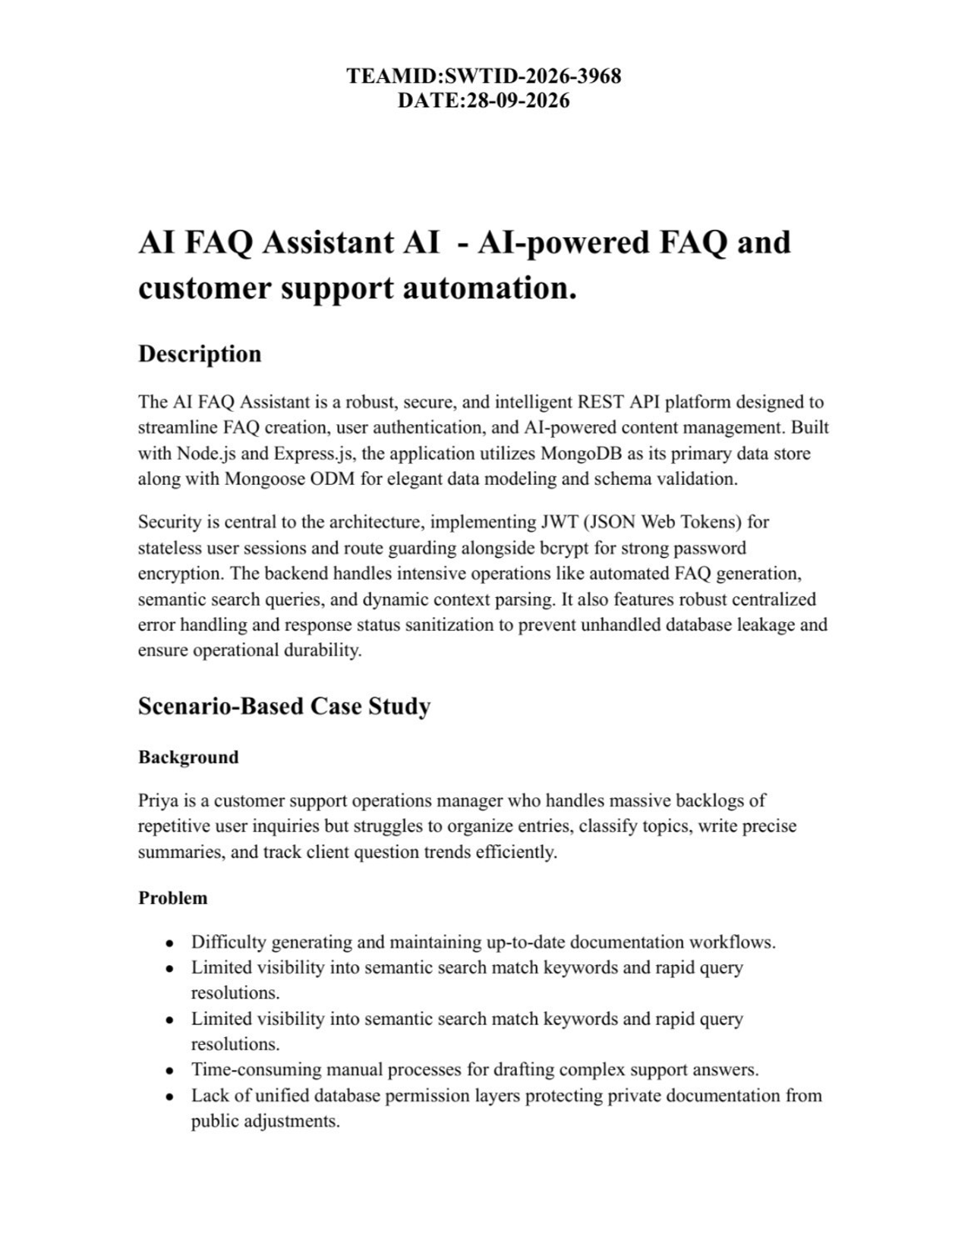

Solution
The backend delivers a centralized, secure API wrapper that decouples
application business logic from frontend delivery systems. It introduces internal verification matrices controlling specialized services for content creation, category keywords, database persistence, and .

Usage
● Authenticated Creator Usage: Registers profiles, requests instant AI assistance, drafts official FAQ schemas, and updates or removes self-authored records.
● Public/Consumer Usage: Queries general list routes to consume published articles and issues localized semantic queries via parameters.

Outcome
By offloading workflow controls to a robust backend, operational delays are minimized. Data structural integrity is strictly maintained through automated schema validation, security tokens guarantee that only original authors modify documents, and high-performance indexing facilitates real-time data discoverability.

1. Software Requirements
● Operating System: Windows 10/11, macOS, or Linux (supports cross-platform operations).
● Node.js (v18 or above): Runtime ecosystem running server logic and routing infrastructure.
● npm (v9 or above): Node package manager to control operational dependencies.
● Express.js (v4/v5 Ecosystem): Lightweight routing web framework to construct backend RESTful entry points.
● MongoDB / Mongoose ODM: Document NoSQL engine storing application users and curated data entities.
● Postman / ThunderClient: API verification toolkit to assert schema validation responses across administrative route shields.
● Code Editor: Visual Studio Code or similar IDE environment.

2. Hardware Requirements
● Processor: Intel Core i5 (8th Gen or above) / AMD Ryzen 5 or equivalent.
● RAM: 8 GB minimum (16 GB recommended for concurrent instances of MongoDB processing layers).
● Storage: 1 GB of available disk workspace.

Epic-1: Project Architecture
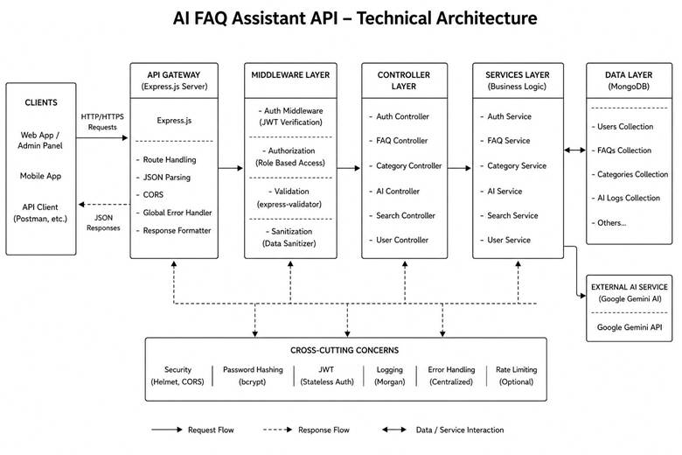
The application exposes structured endpoints handled by a layered
server architecture model. Incoming requests undergo filter processing before interacting with data services.

Components Definition
● Interface: API tools like Postman query distinct route paths to extract JSON entities.
● Express Server Gateway: Monitors network ports, maps explicit HTTP methods (GET, POST, PUT, DELETE), parses incoming JSON payloads, and handles CORS headers.
● Authentication Middleware: Extracts tokens from headers, validates user context signatures, and evaluates authorization thresholds for guarded resource paths.
● Granular Services (Logic Modules): Enforces isolated domain rules for user session life cycles and operational query modifications.
● Database Interface Layer: Mongoose translates operational application logic into performant native MongoDB queries.
●

Entity-Relationship (ER) Diagram Description
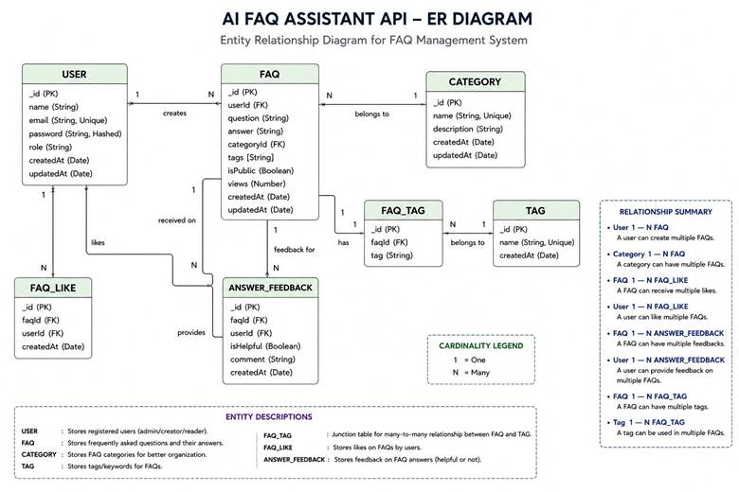
The backend database consists of multiple MongoDB collections connected through logical references to maintain user authentication, FAQ management, AI-generated content, and category organization.

1. User Entity
● _id (Primary Key - ObjectId)
● name (String, Required)
● email (String, Required, Unique)
● password (String, Hashed, Required)
● role (String, Default: "user")
● createdAt
● updatedAt

2. FAQ Entity
● _id (Primary Key - ObjectId)
● question (String, Required)
● answer (String, Required)
● category (String, Required)
● createdBy (Foreign Key referencing User Collection)
● createdAt
● updatedAt

3. ^{FAQ Activity Entity (Logical)}
( )
● topic (String)
● (String)
● (String)
● (String)
●

4. Category Entity (Logical)
● categoryName (String)
● description (String)
● totalFAQs (Number)

Key Structural Mappings
User → FAQ (One-to-Many):
A registered user can create and manage multiple FAQ records.
Category → FAQ (One-to-Many):
Each category can contain multiple FAQ documents.
User → (One-to-Many):
A user can generate multiple AI-assisted FAQs, which may later be saved into the FAQ collection.
FAQ → Search Results (Logical Relationship):
Search queries retrieve matching FAQ documents using keyword and semantic matching.

Key Features
● JWT Authentication & Authorization: Secure token-based authentication protects private API endpoints.
● :

● Semantic FAQ Search: Intelligent keyword-based search enables faster information retrieval.
● Complete CRUD Operations: Create, Read, Update, and Delete FAQ records.
● Category Management: Organizes FAQs into structured categories for easier navigation.
● Password Encryption: User passwords are securely hashed using bcrypt before storage.
● Centralized Error Handling: Standardized API error responses improve reliability and debugging.
● Schema Validation: Mongoose validation ensures data integrity before database persistence.
● RESTful API Architecture: Modular Express.js routes provide scalable backend services.
● MongoDB Integration: Efficient NoSQL document storage using Mongoose ODM.

Roles and Responsibilities

Admin
● Manage all registered users.
● View, update, and delete any FAQ.
● Monitor AI-generated content.
● Manage FAQ categories.
● Access complete system functionality.

Content Creator
● Create new FAQs.
● Edit personal FAQ records.
● Delete owned FAQs.
●
● Organize FAQs under categories.

Authenticated User
● View public FAQs.
● Search FAQs using keywords.
●
● Access personal profile information.

Public User
● View published FAQs.
● Search FAQs.
● Cannot create, edit, or delete FAQ records. ● No access to protected API endpoints.

User Flow
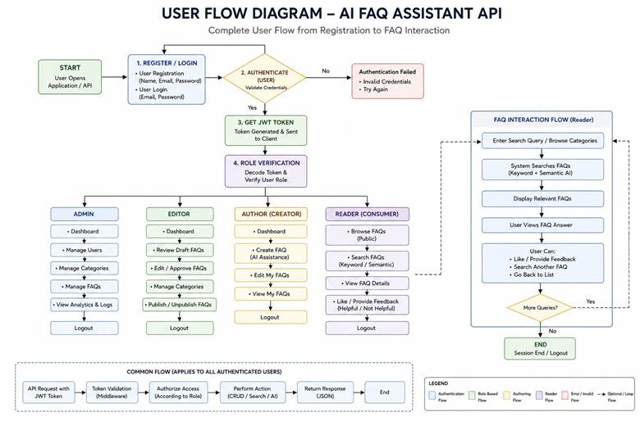

MVC Architecture Pattern
The system architecture structures its source configuration layers around the Model-View-Controller design pattern to completely decouple components:

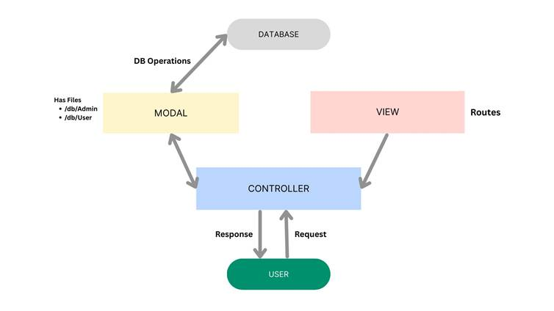

The system architecture structures its source configuration layers around the Model-View-Controller design pattern to completely decouple components:

Model Layer (Data Blueprint)
Defines structural blueprints via strongly enforced Mongoose schemas mapping explicit fields into raw collection items inside MongoDB. It sets field rules and defaults before validation persistence occurs.

Controller Layer (Execution Matrix)
The intermediary brain of the ecosystem. It captures request vectors from execution routes, checks structural request constraints, delegates processing workflows directly to models or services, and packages resultant output into standard JSON return arrays.

View Layer (Routing Network Interface)
In this pure headless backend service context, standard user-interface template views do not exist. Instead, the interface layer lives as an API Routing Layer. It links network requests on specified paths directly to their associated controller handler logic maps.

Epic 2: Project Setup and Configuration

Creating Project Folder
1. Create a new folder with your <project name>.
2. Inside that folder, create a new subfolder named src.
3. Now open that folder in VS Code.
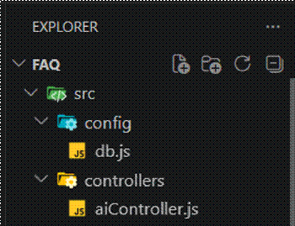

Server Setup (npm init)
Open your root folder terminal in VS Code and run:
Bash

npm init -y
npm install express mongoose dotenv cors jsonwebtoken bcrypt @google/genai

File and Folder Structure Matrix
Plaintext
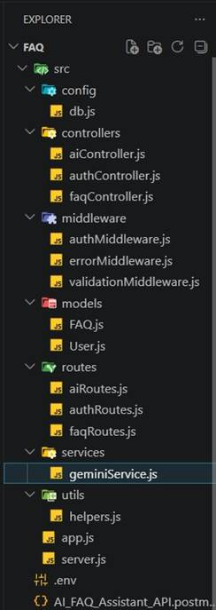

Epic 3: Backend Development

Core System Script Implementations

1. Gateway Server Node (src/server.js)
This main entrance mechanism aggregates environment variables, triggers database listeners, and binds network listeners to active environment ports:
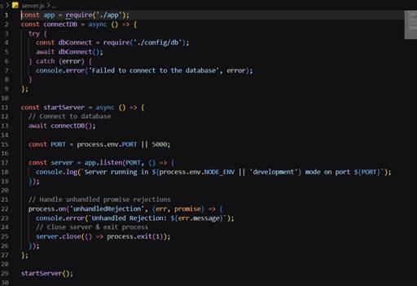
2. Gateway Express Setup (src/app.js)
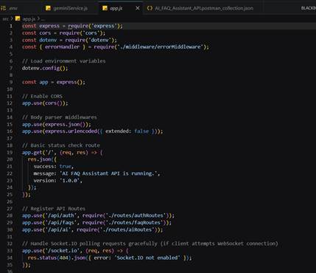

3. Security Access Middleware (src/middleware/authMiddleware.js)
Intercepts incoming target queries, extracts transmission header authorization records, and validates token identity context claims:
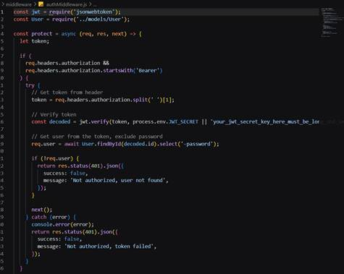

4. Centralized Error Handler Middleware (src/middleware/errorMiddleware.js)
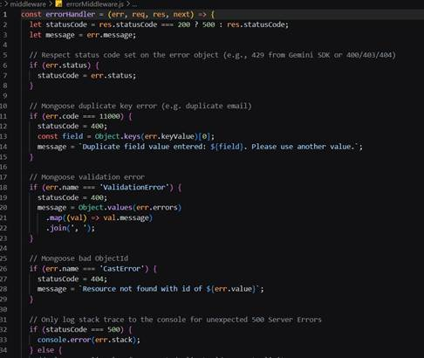

Epic 4: Database Configuration

Mongoose Schema Definitions

1. Identity Resource Document Schema (src/models/User.js)
Enforces profile field criteria validations and hooks password hashing steps prior to user document persistence:
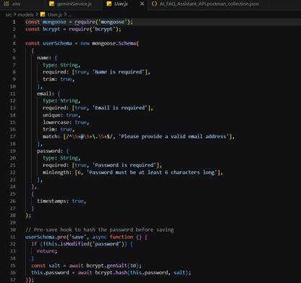

2. FAQ Resource Document Schema (src/models/FAQ.js)
Models core properties and maps a distinct relational reference link back to the source creator document:
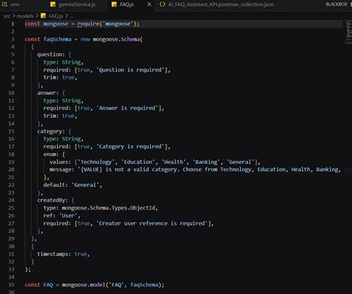

API Router Interface Endpoints

1. Public Authentication Operations (src/routes/authRoutes.js)
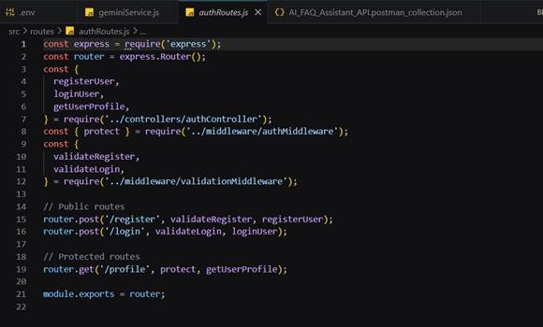

2. Protected FAQ Operations (src/routes/faqRoutes.js)
JavaScript
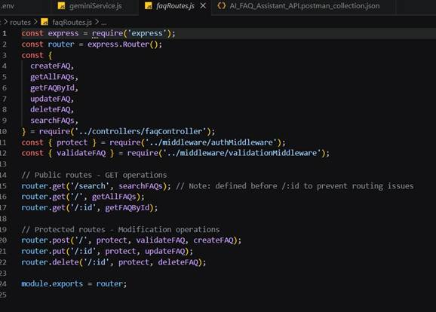

3. (src/routes/aiRoutes.js)
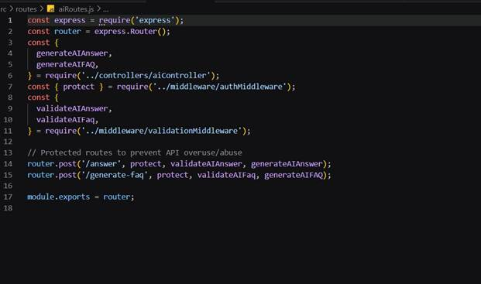

Epic 5: Project Executions

Running the API Application
● Install Postman or ThunderClient (VS Code extension).
● Start the backend development server environment parameters:
Bash

npm run dev

API Testing Specification Demo
To verify operational structural integrity via execution endpoints, map endpoints using the configurations below:

1. Identity Onboarding Path Registration
● Route: POST /api/auth/register
● Access: Public
● Payload Request Body JSON:
JSON

{

"name": "Priya Sharma", "email": "priya@writeflow.com", "password": "securepassword123" }

2. Profile Login Verification Quey
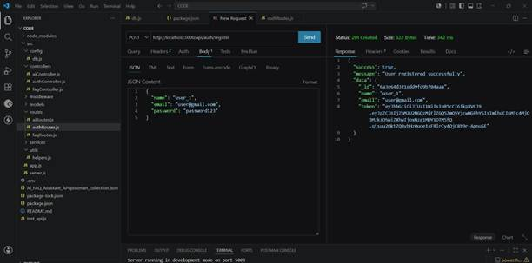
● Route: POST /api/auth/login
● Access: Public
● Payload Request Body JSON:
JSON

{

"email": "priya@writeflow.com", "password": "securepassword123"
}
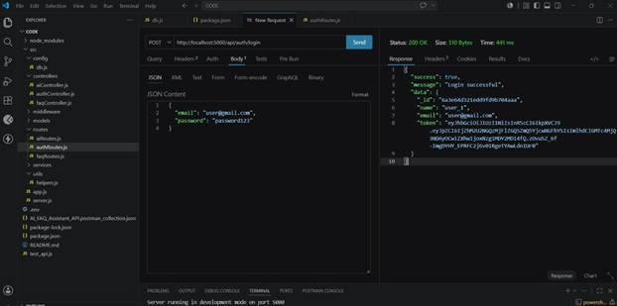

3. Resource Entity Creation (FAQ)
● Route: POST /api/faqs
● Access: Private (Bearer <JWT Token>) ● Payload Request Body JSON:
JSON

{

"question": "How do I configure custom category tags?", "answer": "Navigate to settings panel, append keyword tags arrays, and save schema.", "category": "Configuration"
}
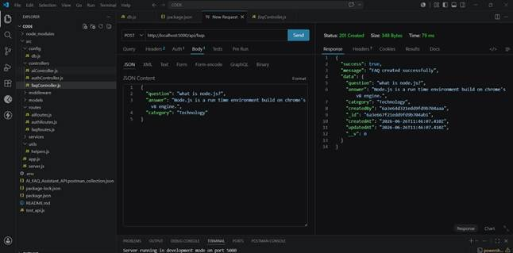

4. Keyword Resource Entity Fetching (Search)
● Route: GET /api/faqs/search?q=configure
● Access: Public

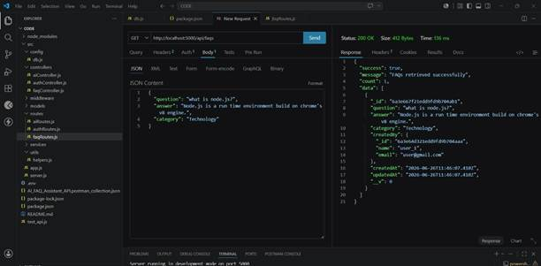

5.
● Route:
● Access: Private (Bearer <JWT Token>) ● Payload Request Body JSON:
JSON

{

}

Code Drive:AI FAQ
Demo video:Demo
Testing video:Testing

